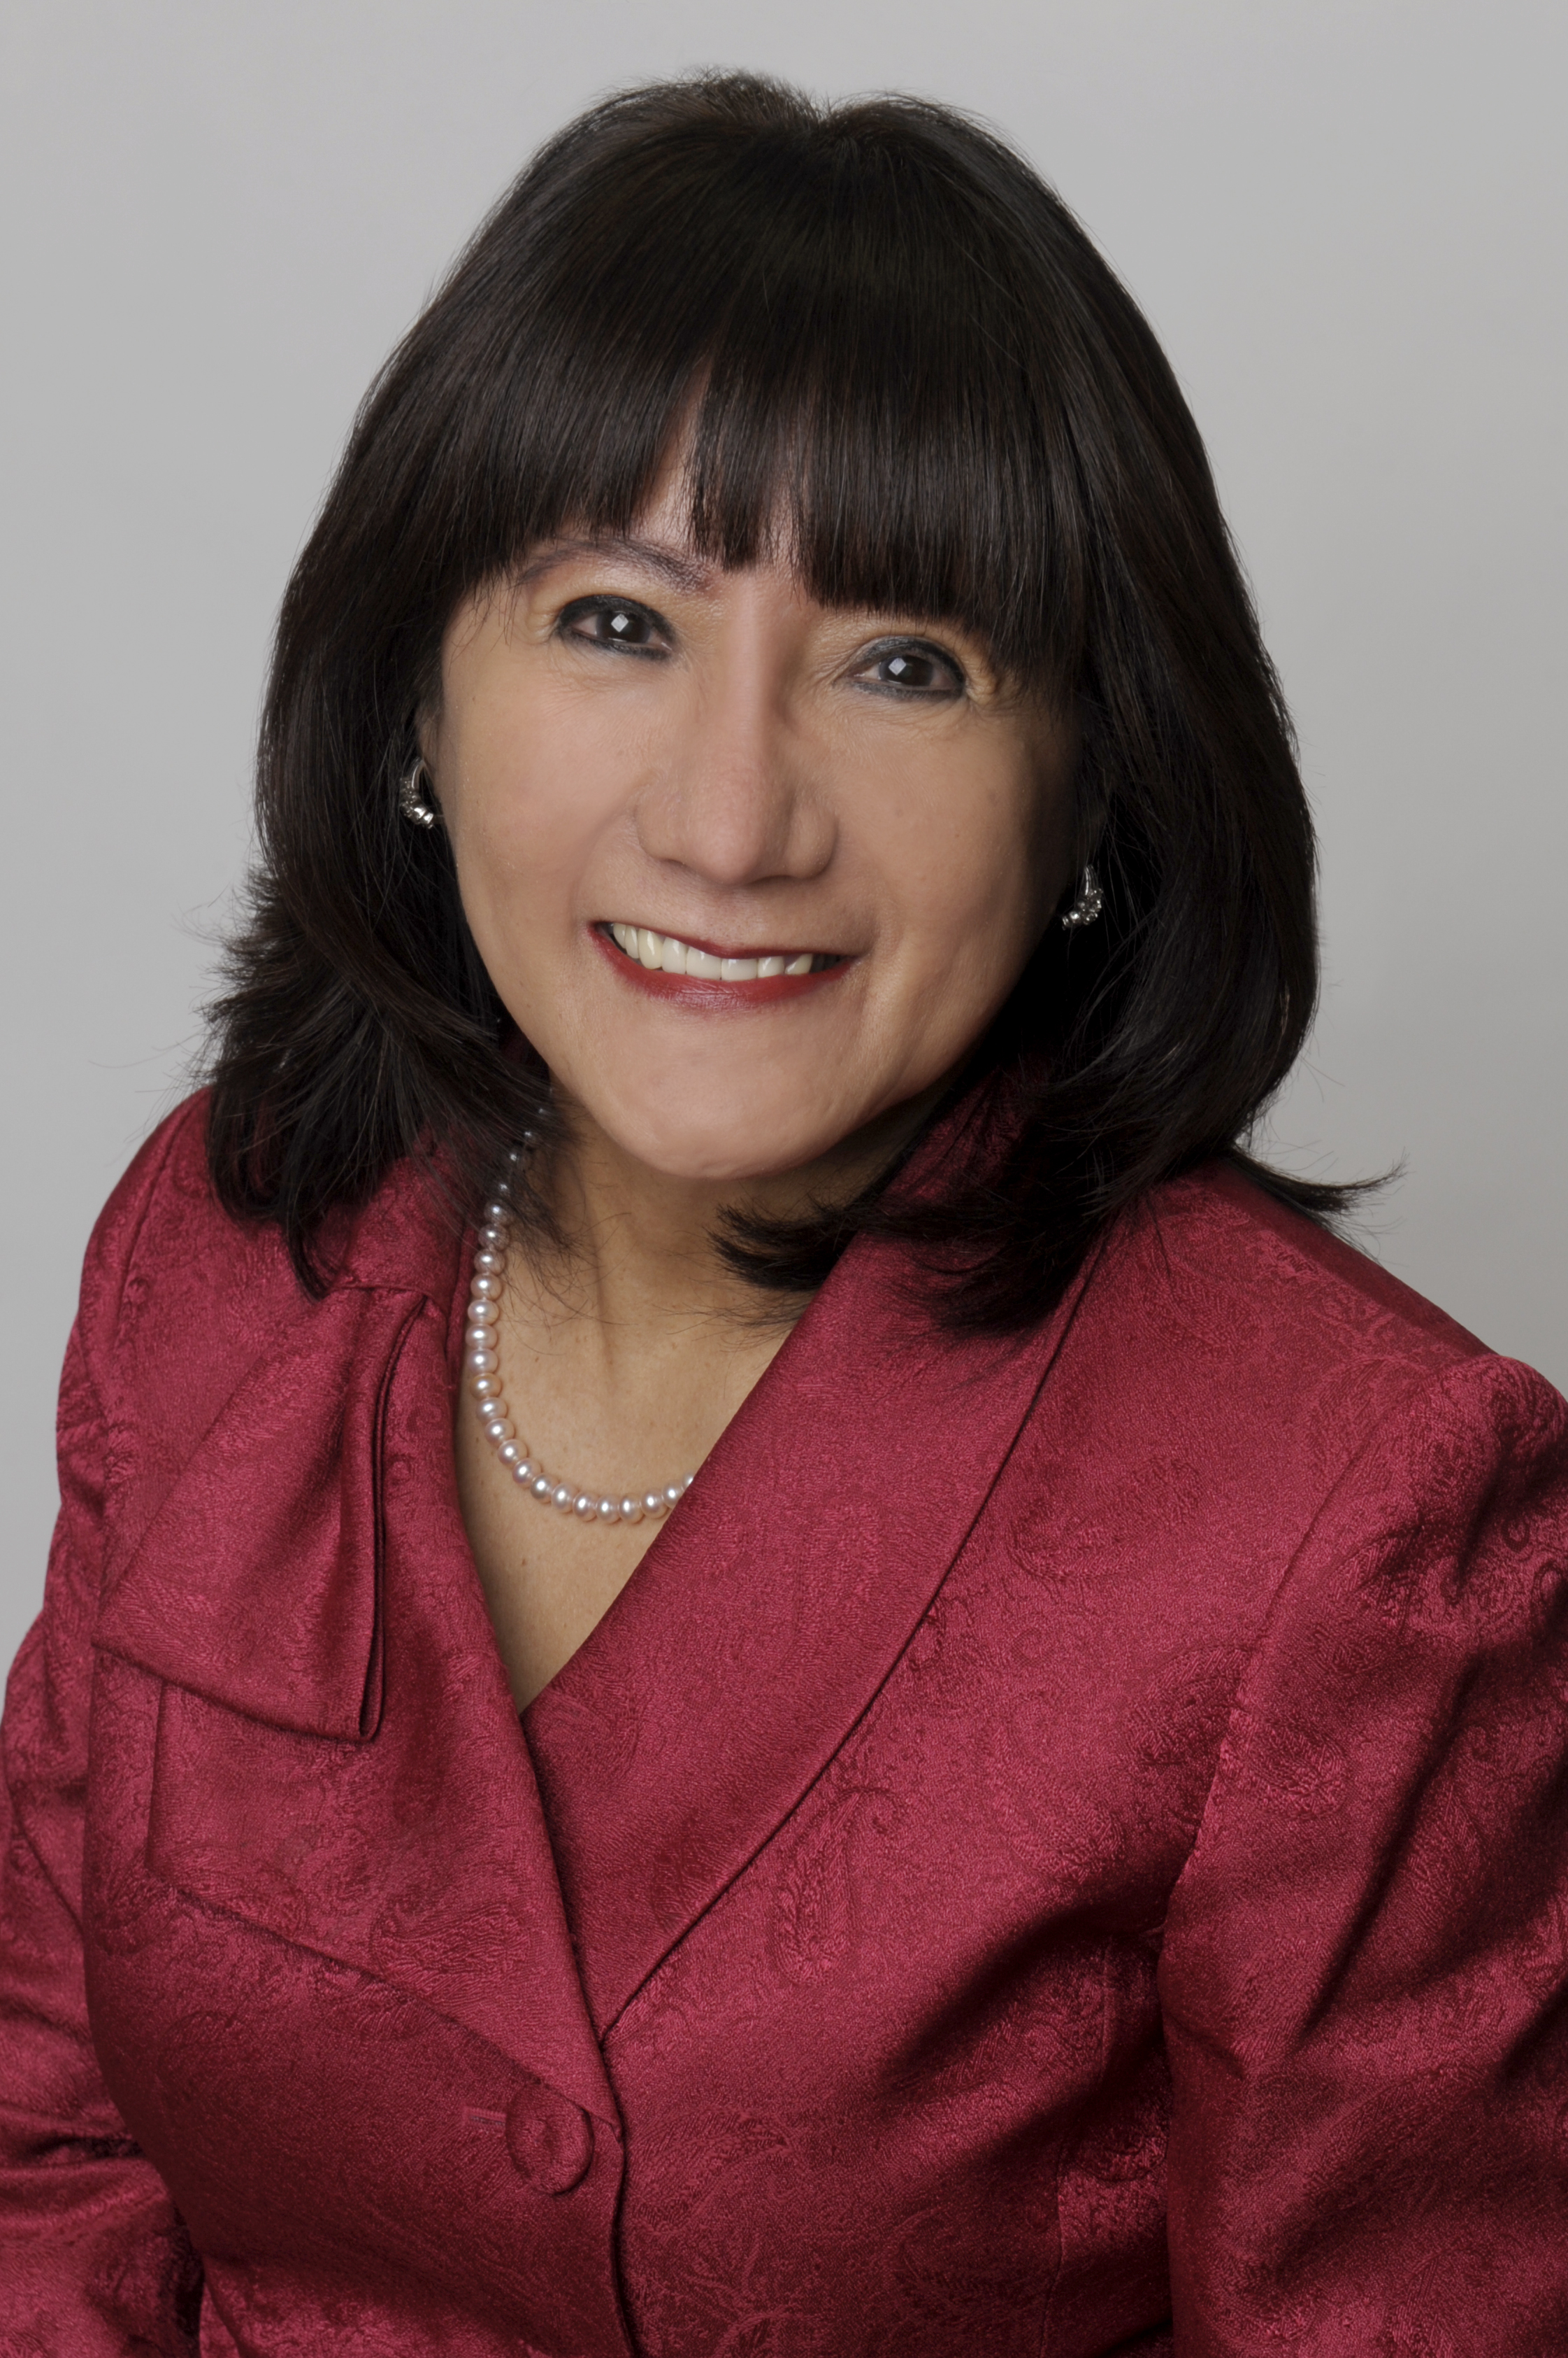

**Luz del Rosario**  
Chair of the Board of Trustees Trustee, Mississauga  
Wards 6 & 11  
(416) 528-6447  
luz.delrosario@dpcdsb.org



**AGENDAS AND MINUTES**[**Board and Committee Meetings**](https://www.dpcdsb.org/news/board-meetings)



**Dufferin-Peel Catholic District School Board**  
40 Matheson Blvd. W.  
Mississauga, ON L5R 1C5  
905-890-1221  
[dpcdsb.org](https://dpcdsborg-my.sharepoint.com/personal/50212_educ_dpcdsb_org/Documents/DPCDSB%20Visual%20Branding%20and%20Templates/Letterheads%20and%20Memo%20-%20Editable%20Templates/dpcdsb.org)

[](https://www.facebook.com/DPCDSBSchools/) [](https://twitter.com/DPCDSBSchools) [](https://www.instagram.com/dpcdsb.schools)

Our DPCDSB Mission: Disciples of Christ, nurturing mind, body and soul to the fullness of life.  
Our DPCDSB Vision: Changing the world through Catholic education.

**February 2025**

The Dufferin-Peel Catholic District School Board (DPCDSB)’s virtue of the month in February is **RESPECT.** One of the greatest expressions of love is respect for others. May we draw closer to Christ and see Him in the goodness of others.

**Black History Month** – Both Federal and Provincial governments recognize the importance of Black History Month.  As Canadians and, more importantly, as a Catholic community, we are called to live in solidarity. Solidarity requires that we learn from, and about, our brothers and sisters in Christ. Regardless of the demographics of your school community, Black history is a conversation we must all be present to as it is everyone's history.  
Our DPCDSB schools are hosting many engaging events and initiatives to celebrate Black History Month, including the Black Futures Speakers Series, author read-alouds and workshops. In addition, DPCDSB is encouraging all educators to commit to learning and teaching Black history, not just in February, but throughout the year.

**If we**

**one another,**

**God lives in us. – 1 John 4:12**

**love**

**February is Psychology Month –** DPCDSB psychology staff help students thrive every day by supporting their learning, behaviour and mental health. For more information and resources please visit: School Mental Health Ontario: <https://smho-smso.ca/>

**National Catholic Health Care Week** – This year’s celebration takes place from February 2 - 8 in recognition of the important work of Catholic health care organizations in our province and across Canada. The 2025 theme, *“Caring for our Common Home”*,celebrates the interconnectedness of all creation and helps us to reflect on how our individual and collective actions and our systems - health, social, economic - can promote a healthy world where all can thrive. It emphasizes the integral connection between human health and the health of the planet, echoing Pope Francis’ call to care for the earth as our common home in *Laudato Si*. [Learn more](https://www.chac.ca/en/national-catholic-health-care-week/).

**Student Device Refresh Plan** - During the pandemic, DPCDSB schools received a number of devices supported by Ministry of Education one-time funding initiatives. The funding supported the purchase of devices for staff and students. Unfortunately, there was no follow-up funding from the Ministry to address repairs, replacements or End of Life (EOL). The majority of technology devices intended for student use in DPCDSB schools are coming to their EOL and it is necessary to replace them. DPCDSB utilizes all central funding available for device deployment at schools but has also been operating on a decentralized funding model for devices, where schools have responsibility for securing and maintaining their own inventory of devices. To achieve a fair and equitable student-to-device ratio, DPCDSB is moving to a centralized model:

* Grades JK-2 > 4:1 (one device for every four students)
* Grades 3-6 > 2:1 (one device for every two students)
* Grades 7-12 > 1:1 (one device for every student)

Starting in the current 2024-2025 school year, DPCDSB will begin to replace devices in the elementary panel. This refresh cycle will take place over a four-year period to reach the ratios indicated above. This also means that there will be a gradual deployment of devices in secondary schools starting in the current 2024-2025 school year with a 1:1 student to device ratio for the current Grade 9 cohort. Achieving a 1:1 ratio for all secondary grades will happen by the 2027-2028 school year. In addition to security concerns, outdated software, limited technological support, the need for DPCDSB to support online EQAO testing, digital math tools and to deliver technology curriculum requirements from the Ministry of Education, this centralized procurement and device management plan helps ensure that all students will have equitable access to current technology that is critical to today’s learning and teaching environments.

**Catholic Board Improvement Learning Cycle –** DPCDSB promotes learning and working environments that support a responsive, equitable, inclusive and caring culture through its Multi-Year Strategic Plan (MSYP), Catholic Board Improvement Learning Cycle (CBILC) and Catholic School Improvement Learning Cycles (CSILC). DPCDSB’s Infographic CBILC Fact Sheets highlight progress within each of the five MYSP values – Believe, Excel, Respect, Thrive and Trust. These core values continue to shape the CBILC and CSILC goals, the implementation of action steps and their monitoring strategies. For each of the MYSP’s five core values, DPCDSB schools engage in a cycle of continuous improvement by examining local data, developing and implementing responsive action steps, and assessing a variety of data sources to monitor goal achievement and ensure accountability. To complement local data gathering by schools to support improvement planning, DPCDSB regularly administers large-scale surveys to collect data about student attitudes and experiences. DPCDSB data gathering in 2023-2024 included:

* Ontario Catholic Graduate Expectations Survey (OCSGE) and Exit Survey
* Math and Literacy Processes, Attitudes and Engagement Survey
* Middle Year Development Instrument (MDI)
* Catholic Digital Citizenship Survey

Additionally, the Ministry of Education requires school boards to seek feedback regarding their MYSPs from parents, guardians, students and other community members. This feedback helps DPCDSB continue to prioritize what is important to students and their families. Finally, data from the Education Quality and Accountability Office (EQAO) assessments, including the Ontario Secondary school Literacy Test (OSSLT), help DPCDSB focus on where students need greater academic support. This wide range of data informs DPCDSB local and system-wide actions and commitment to the core MYSP values concerning Catholic social teachings, achievement, social justice, well-being and stewardship. The finalized 2023-2024 CBILC Fact Sheets are available on the board website.

**Supporting Students’ Reading Development** – In 2019, the Ontario Human Rights Commission (OHRC) initiated an inquiry into how children are taught to read in Ontario. This inquiry was prompted by concerns over the effectiveness of reading instruction and its impact on student outcomes. The inquiry was a response to growing disparities in reading achievement across the province, particularly for students with learning disabilities, those from marginalized communities and English Language Learners. The OHRC’s goal was to investigate whether current teaching practices in reading were meeting the needs of all students, and to identify any systematic barriers that might be hindering students’ literacy development.

In 2022, the OHRC released its findings in the “*Right to Read Inquiry Report*” which concluded with 157 recommendations for all education stakeholders aimed at improving reading instruction and ensuring that all students had an equal opportunity to learn to read. Among the key recommendations were the implementation of early reading screeners, a focus on explicit, systematic instruction in phonics and decoding skills, and a more structured approach to teaching reading comprehension.

In response to the OHRC’s recommendations, the Ministry of Education (the Ministry) revised the Ontario Language Curriculum Grades 1 to 8. The new language curriculum emphasizes a focus on teaching foundational reading skills found in Strand B through evidence-based practices. Additionally, the Ministry is committed to updating the expectations in the kindergarten program by 2025 to align with the changes that have been made in the Grade 1 to 8 language curriculum. In addition to the changes in the Language Curriculum, the Ministry also released Policy/Program Memorandum (PPM) 168 that mandated 30 minutes of uninterrupted language instruction each day for students in Grade 1 to 3. It also stated that all students in kindergarten (Year 2) to Grade 2 are to be screened, to identify early signs of reading difficulties and allow for timely intervention. All students are required to be screened at the beginning of the year and those students who do not meet the benchmark will be screened again in March.

The results from the screener reflect a positive trend in early literacy development across DPCDSB:

* In kindergarten, 80% of the students are performing at or above the benchmark, demonstrating strong foundational reading skills in letter naming and first sound fluency.
* In Grade 1, 44% of the students are performing at our above benchmark, demonstrating strong foundational reading skills in phoneme segmentation and word reading.
* In Grade 2, 65% of the students are performing at or above the benchmark, demonstrating strong foundational reading skills in oral reading and retell.

DPCDSB is fully committed to supporting all students, particularly those who are below the benchmark in early literacy. The importance of early identification and intervention is key in ensuring that every student can succeed in reading and literacy. As part of DPCDSB’s ongoing commitment, efforts are focused on providing teachers with professional development and providing comprehensive resources to support teachers in delivering effective instruction at all tiers of

intervention. Program and Learning Services has responded by placing Literacy Facilitators trained in Empower, a Tier 3 intervention program, to support the highest-needs schools for the rest of the school year. DPCDSB will continue to provide an environment where every student can develop strong reading skills and thrive academically.

**Integrating Artificial Intelligence in DPCDSB** – Artificial Intelligence (AI) is transforming how we live, work, and learn and offers significant opportunities to revolutionize education. By enabling personalized learning, improving classroom efficiency, and introducing innovative assessment methods, AI unlocks new possibilities. Its integration within the school board supports DPCDSB’s commitment to fostering knowledge and excellence, as outlined in the MYSP. However, AI also presents challenges, including ethical concerns, privacy issues, and its impact on instructional practices. As educators explore the role and potential of generative AI, they are engaging in ongoing discussions about its effects on creativity, academic integrity, and copyright. Thoughtfully addressing these complexities ensures that AI becomes a tool for equity, innovation, and integrity in education.

Generative AI became widely accessible in November 2022 with the introduction of ChatGPT, sparking significant interest and possibilities in education. DPCDSB’s Program and Learning Services department responded to initial concerns about academic integrity and instructional disruptions by creating an introductory video in 2023. This foundational resource introduced generative AI. It highlighted the strengths and limitations of AI and demonstrated practical integration into education. Influenced by Pope Francis' message to align AI use with our Catholic social teachings, DPCDSB is exploring the potential of AI to serve students in their education and understanding of their responsibilities. In this regard, we have achieved the following milestones:

* DPCDSB AI Guidelines for Educators - Released in November 2023, it supports the MYSP goal of cultivating knowledge and brilliance by providing a framework for ethical and effective AI use in education. Developed using research and best practices from provincial post-secondary institutions, these guidelines will be continually updated to reflect emerging insights.
* Comprehensive SharePoint page – This serves as a centralized repository for AI resources, supporting student achievement and well-being by providing educators with access to innovative tools and materials.
* Professional Development and Professional Learning Series – AI has been addressed on Provincial Professional Activities Days as areas of new learning for staff. In addition, an optional four-part professional learning series was developed to equip educators with a greater understanding of how to integrate AI into their teaching practices, which supports the MYSP goals of cultivating knowledge, respect, and well-being.

DPCDSB is committed to advancing its AI initiatives with the following goals:

* Launch Co-Pilot for Educators: Microsoft Copilot will be introduced to educators alongside training sessions focused on ethical considerations and practical applications.
* Pilot Additional AI Tools: Evaluate tools to determine their effectiveness in enhancing teaching practices and supporting educators.
* Development of Student Resources: Infographics and resources focusing on ethical considerations, responsible use, and academic integrity will be created for students.
* Quick Learning Resources: Resources such as trailers, micro-videos, and mini podcasts will be developed to support educators and students in prompt engineering, maintaining academic integrity, and engaging effectively with AI.

By embracing innovation and adaptability, DPCDSB is paving the way for transformative educational practices, ensuring that AI serves as the tool Pope Francis envisioned it as in promoting equity, integrity, and innovation – all hallmarks of a Catholic education DPCDSB aspires to providing for its students.

**Edwin Digital Tool** – In 2018, DPCDSB partnered with Nelson Publishing to pilot Edwin, a digital learning platform designed to enhance teacher instruction, student engagement and achievement. Today all Grade 6/7, 7 and 8 classes in DPCDSB provide the Edwin learning platform to students through an individual Chromebook to access this learning platform. Edwin provides DPCDSB students with equitable access to 21st century, inquiry-based learning, aligning seamlessly with the Ontario Catholic School Graduate Expectations (OCSGE) and supporting the development of global competencies.

The Edwin application features the Edwin library, a curated and continually updated collection of accessible, interactive, culturally relevant and responsive resources aligned with the Ontario curriculum. The Edwin application allows students access to all Nelson textbooks in all subjects. These resources include text-based materials, videos, collections, math tools, and interactive PhET (Physics Education Technology) simulations that allow for digital lab experiences, all with built-in accessibility tools to accommodate diverse interests, learning styles, and needs. By integrating the Edwin platform, DPCDSB has enhanced the educational experience of students by fulfilling the strategic goals of the Multi-Year Strategic Plan (MYSP), specifically the *Excel* and *Thrive* pillars, to foster a holistic and supportive learning environment for all students.

In 2019-2020, after a free year of use in the pilot, the cost of Edwin was $2,679,418. The 2020-2021 cost was $2,746,531. Throughout the COVID-19 pandemic, the Edwin devices were pivotal in enabling DPCDSB to respond to online learning and protect the education of students. The COVID-19 pandemic had an unexpected impact on the educational publishing business. Publishing companies responded to the pandemic with more and more digital textbooks, moving away from affordable and available print texts given the cost effectiveness of online materials. The Edwin platform ensured that DPCDSB students had access to the most current and effective curriculum materials. The 2021-2022 costs were $3,440,092. These terms involved hardware, software and white glove service cost. In 2022-2023 the cost for Edwin was $1,686,130 and in 2023-2024 it was $1,492,344. The changes in the costs of the platform reflect the fact that DPCDSB purchased and maintained its own hardware and that costs for Nelson were only for the digital Edwin license. As Nelson had moved away from a model of providing hardware and licenses to only providing digital licenses for their materials, DPCDSB managed hardware costs separately. The platform of providing access to all texts required for Grades 6/7, 7 and 8 collections, virtual manipulatives, teacher support, and the opportunity to work with the company to develop and elevate the importance of Catholic education, made continued employment of the Edwin platform essential for student success. Its continued usage is key to ensuring students have equitable access to curriculum that is current, accurate and relevant given they must learn to navigate a world where these qualities are often challenged. Quantitative data has demonstrated that students feel more engaged and responsible for their learning when assigned their own device that accesses Edwin for them as they need it during school, and after. Homework is completed in a digital environment that supports ongoing learning. Qualitative research on the impact of Edwin on student achievement is ongoing as the pandemic has impacted initial results. Usage data provides insight into the relevance of materials available and where support is required for teachers and students. The Program department continues to review all products for their value and cost effectiveness and most importantly for their impact in providing the best Catholic education we can offer students within DPCDSB.

**OCSTA Resolutions** – Each year the Ontario Catholic School Trustees’ Association (OCSTA) requests draft resolutions for consideration at its Annual General Meeting (AGM). The resolution process provides member boards with the opportunity to bring forward important issues, which have provincial implications, to the attention of all trustees in the province. The study and processing of resolutions is one of the fundamental responsibilities of OCSTA. Our DPCDSB trustees are asked to submit resolutions for consideration. Any resolutions brought forward are then considered for approval at a meeting of the Board of Trustees. Once finalized, all resolutions are submitted to the Board of Trustees prior to being submitted to OCSTA for consideration at the annual general meeting (AGM). More information is provided in the January 14, 2025 - Faith and Program Committee Meeting which is available on the board website.

1. Funding to Support Additional Supervision
2. Technology Funding
3. Student Transportation Funding
4. Funding for Retrofitting/Renovating Schools
5. Funding to Lower Class Sizes in Grades 4 through 8
6. Review Moratorium on School Closures
7. Review of Policies on Trustee Attendance at Board Meetings
8. Internet Safety for Students

**Bylaw and Policies Review** – The following DPCDSB bylaw and policies were approved and adopted at the Regular Meeting of the Board of Trustees on January 28:

Policy 8.06: Flag Protocol

Policy 4.04: Educational Excursions

Policy 1.85: Child Care in DPCDSB

Policy 1.90 Child Care – Selection and Appointment of Third Party Providers - rescinded

Policy 7.14: Opening Exercises in Schools and at Formal Meetings

Policy 19.02: Work Year For Principals and Vice Principals – new policy

Policy 1.75: Chapels in Secondary Schools

Policy 6.80: Co-curricular and Extracurricular Programs

Policy 7.19: Dress Code and School Uniforms

Safe Schools Policies as amended 1) Policy 9.01: Catholic Code of Conduct, 2) Policy 9.02: Bullying Awareness, Prevention and Intervention 3) Policy 9.03: Progressive Discipline, 4) Policy 9.04: Delegation of Authority, 5) Policy 9.05: Victim’s Rights, 6) Policy 9.06: Fresh Start, 7) Excursion Pending Completion of a Police Investigation

**Parent Engagement with Peel Regional Police** – DPCDSB and Peel Regional Police will partner to host two in-person parent engagement evenings in the spring. Both evenings will feature the same agenda but will be hosted at one Mississauga and one Brampton location. Topics for the evening will include human trafficking, drug education, and cyber bullying with an opportunity for a Q&A by those in attendance. Planning has already begun and more information will be shared with our school communities when dates are finalized.

**BSA Event at Mississauga South Family of Schools** – On Friday, February 7, 2025, St. Joseph Catholic Secondary School hosted the Mississauga South Family of Schools’ BSA Event. We welcome back Matthew ‘Testament’ Jones, Ontario’s 2nd Poet Laureate and St. Joseph CSS alumni with his beatboxer friend (Killa beatz) from PEACE, (People Everywhere Actually Coexisting Equally to celebrate black excellence, black resistance and black joy through their theme for 2025 “Start with Love.” Students from Loyola CSS, Iona CSS, St. Paul CSS, St. Oscar Romero CSS and St. Joseph CSS participated. See some pictures I took below:

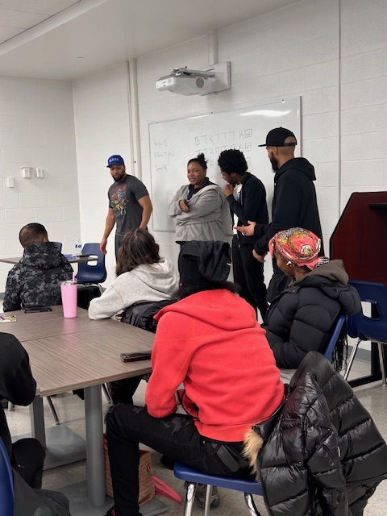 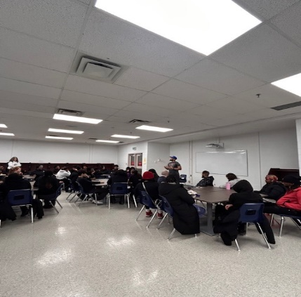 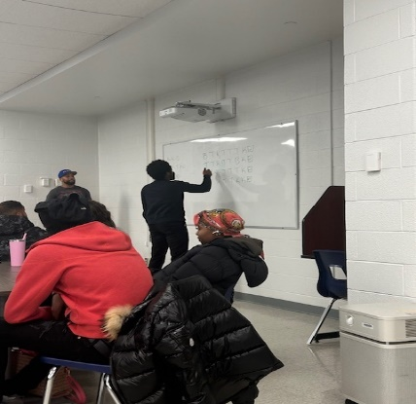

Wishing our DPCDSB students, families, and staff a happy Family Day! May it be an enjoyable day spent with family, friends and loved ones.

Thank you for choosing a Catholic education for your family.

Take care and God bless you always.

**Luz del Rosario**

**Luz del Rosario**Chair of the Board of Trustees  
Trustee, Mississauga Wards 6 & 11